MCLAREN STRATEGIC SOLUTIONS
Ohio Medicaid Fiscal Intermediary — CEF Platform
Target State Architecture
C4 view pack and container traceability — repository-preserving
Target-state counterpart to CEF-CAP-TAD-001, drawn to the same conventions and container identifiers
Field | Value
Document ID | CEF-MOD-TAD-001
Revision | rev 3.0 — DRAFT
Date | 8 September 2026
Parent instrument | CEF-CAP-TAD-001 — Capitation E2E Current State v4. Container IDs, conventions and findings are inherited from it.
Companion instrument | CEF-MOD-EXEC-001 — technology direction, phasing and business case
Modelling constraint | The repository estate does not change. Containers CAP-C4-CON01 to CON12 are preserved; only the technology inside them changes.
Views | Seven, complete: V-T01 (L1), V-T02 (L2 container), V-T03 (L3), V-T04 (L4), V-T05 and V-T06 (L2 dynamic, stage and container grain), V-T07 (L2 deployment)
Open items | Five, listed with owners at §8.1. V-T07 rests on ADR-011, which is Proposed not Accepted.
Inherited gap | CEF-CAP-TAD-001 §0.7 container boundary rule remains unanswered and is inherited, not closed
Runtime baseline | .NET 10 LTS · React 19.2 · Next.js 16.3 · PostgreSQL 18.6 · Apache Kafka 4.3.1
Classification | MSS / Gainwell Confidential — not for State distribution without review

What this document does
It specifies the target state architecture for the capitation platform as a complete C4 view set, mapped one-to-one onto the containers and repositories established in CEF-CAP-TAD-001. The repository estate does not change; the technology inside it does.
Read §3.1 first — the container traceability table is the contract between current and target state, and every other section depends on it holding. Read §8 before estimating any of this work.
Four constraints are carried forward unresolved and five items are open. They are listed at §8 with named owners rather than closed on paper, because the current-state evidence does not support closing them.

Contents
1. Scope and modelling constraint
1.1 What this pack contains
1.2 The repository estate does not change
1.3 Technology baseline
2. Modelling conventions
2.1 Alignment with CEF-CAP-TAD-001
2.2 The container boundary rule
2.3 Target view index
3. Container traceability
3.1 Current container to target container
3.2 Reading the traceability honestly
3.3 Repository disposition
4. Architecture views — C4 Levels 1 and 2
4.1 V-T01 — Target System Context
4.2 V-T02 — Target Container view
5. Engineering views — C4 Levels 3 and 4
5.1 V-T03 — Component view, CAP-C4-CON01
5.2 V-T04 — Code view, the voucher and payment write path
6. Dynamic views — C4 Level 2
6.1 V-T05 — Target end-to-end capitation, stage grain
6.2 V-T06 — Target regular monthly cycle, container grain
7. Deployment view — C4 Level 2
8. Constraints and open items
8.1 Open items
9. Consistency check
10. Actions

1. Scope and modelling constraint

1.1 What this pack contains
A complete target-state C4 view set for the CEF capitation platform, expressed against the container model and repository estate established in CEF-CAP-TAD-001. Seven views are drawn: system context, container, component, code, and dynamic views at both stage and container grain, plus deployment.
Container identifiers CAP-C4-CON01 to CAP-C4-CON12 carry the same meaning here that they carry at CEF-CAP-TAD-001 §1.3.4. Every current-state finding therefore remains addressable against a target container, and every target decision can be checked against the evidence that produced the finding.

1.2 The repository estate does not change
No repository is created and none is retired by the target design at container grain. mms-cms-cef, sis-inx-edigw, mms-bolton-fin-ohio, act-oh-OHDDI and finance-corticon-businessrules all persist. What changes is the technology inside them and, in exactly one case, which repository owns a container.
This is a deliberate constraint. The repository estate encodes ownership, build lanes, release cadence and audit history. Re-cutting it at the same time as re-platforming the runtime would mean changing two variables at once, and no failure during migration could then be attributed to either. Re-platform first inside the existing boundaries; revisit repository boundaries afterwards, if the evidence then justifies it.

1.3 Technology baseline
.NET 10 LTS, React 19.2 with Next.js 16.3, PostgreSQL 18.6, Apache Kafka 4.3.1, PingOne for identity, Docker and ECS on AWS, GitHub Actions for delivery. All are current generally-available releases; none is a preview.

2. Modelling conventions

2.1 Alignment with CEF-CAP-TAD-001
The conventions at CEF-CAP-TAD-001 §0.7 are adopted without modification, so that the current-state and target-state view sets can be laid side by side.
Question the reader is asking | Notation | Where it lives
What is in scope, who uses it, what it touches outside the boundary | C4 L1 — System Context | §4.1 — V-T01
What separately deployable or executable units exist, and what data stores | C4 L2 — Container | §4.2 — V-T02
What happens, in what order, across containers during a cycle | C4 Dynamic view, container grain | §6.2 — V-T06
Where the containers run | C4 Deployment view, container grain | §7 — V-T07
What sits inside a container and what each part is responsible for | C4 L3 — Component | §5.1 — V-T03
What the code does on the write path | C4 L4 — Code | §5.2 — V-T04

2.2 The container boundary rule
CEF-CAP-TAD-001 records at §0.7 that the container boundary rule — instance grain or database grain — is formally unanswered, and draws V-02 at database grain because two independent places in that document already use that grain. The gap is owned by the Solution Architect.
This instrument inherits the gap rather than closing it. The target views are drawn at database grain to remain comparable with V-02. If the boundary rule is later settled at instance grain, CON03, CON04, CON08 and CON10 collapse in the current-state view and the equivalent target containers collapse with them. That would change the drawing; it would not change any decision recorded here, because the target design separates those stores by ownership regardless of how they are hosted.
[GAP: §0.7 remains open and is inherited by this instrument. Target views are drawn at database grain for comparability with V-02. — owner: Solution Architect]

2.3 Target view index
View ID | C4 level / type | View name | Question it answers | Status
V-T01 | L1 System Context | CEF platform — target operating context | What is inside the boundary, who uses it, which external systems remain | Drawn — Figure 4.1
V-T02 | L2 Container | The twelve containers, re-platformed | What each container becomes, in which repository, on what technology | Drawn — Figure 4.2
V-T03 | L3 Component | CAP-C4-CON01 Capitation Calculation Service | What sits inside the calculation container once the vendor chain is removed | Drawn — Figure 5.1
V-T04 | L4 Code | Voucher and payment write path | What the code does on the write path, and which defect class that removes | Drawn — Figure 5.2
V-T05 | Dynamic, stage grain | Target end-to-end capitation | How CAP-S-01 to CAP-S-15 execute once dispatch is event-driven and correlated | Drawn — Figure 6.1
V-T06 | L2 Dynamic, container grain | Target regular monthly cycle | What happens, in what order, across containers — one step per stage | Drawn — Figure 6.2
V-T07 | L2 Deployment | Target deployment | Where the containers run | Drawn — Figure 7.1

All seven views are drawn at this revision. Two grains are used for the dynamic view deliberately: V-T05 is stage grain, which is independent of the container boundary rule discussed at §2.2, and V-T06 is container grain, drawn to the same database grain as V-T02 so that it inherits that question and introduces no new one.

3. Container traceability

3.1 Current container to target container
This table is the spine of the whole instrument. Every row traces a current-state container to what it becomes, names the owning repository, and states which current-state finding the change addresses.

C4 ID | Current container | Target container | Target technology | Repository | Addresses
CAP-C4-CON01 | Capitation calculation chain — C#/VB.NET agents, CAP-S-03 to S-10 | Capitation Calculation Service | ASP.NET Core 10, EF Core 10; seven method bodies become seven handlers | mms-cms-cef — unchanged | Partially decomposable at 1.3.4; ordering and routing were in vendor config
CAP-C4-CON02 | QFrame host, Distribution Hub, Execution Units, MessageStore — vendor binary, no source | Cycle Dispatch and Event Backbone | Kafka 4.3 topics and consumer groups | mms-cms-cef — unchanged | NOT DECOMPOSED at 1.3.4; dispatch semantics invisible; emitted SQL exists nowhere as text
CAP-C4-CON03 | Plandata_Parallel — seven write paths, four components, three repositories | Capitation Store | PostgreSQL 18, single writer, immutable payment key | mms-cms-cef — unchanged | The PostCap_SplitPayments post-hoc re-key of the primary key
CAP-C4-CON04 | HealthPAS_Common — shared crosswalks and supplemental data on drive K: | Reference and Crosswalk Store | PostgreSQL 18, published as an event-sourced read model | act-oh-OHDDI — unchanged | Shared-store coupling with finance and claims
CAP-C4-CON05 | ETLStageDB rate staging — truncated and rebuilt each cycle | Rate Snapshot Store | PostgreSQL 18, effdate / termdate versioned snapshots | Fed by the MEMIM00065 / MEMSW00013 SSIS families — owning repository NOT ESTABLISHED | The destructive reload that loses the prior snapshot
CAP-C4-CON06 | PostCap procedure suite — Ohio T-SQL, CAP-S-11 | Post-Capitation Adjustment Service | .NET 10 domain code; logic lifted out of the database | act-oh-OHDDI → mms-cms-cef — the one ownership move | PreFundAllocate spanning two databases in one procedure
CAP-C4-CON07 | Finance pipeline — hpfin SSIS packages carrying capitation and claims together | Finance Settlement Service | .NET 10 with Kafka consumers, CAP-S-12/13 | mms-bolton-fin-ohio — unchanged | Forked shared artefact; capitation could not be separated from claims
CAP-C4-CON08 | Flexi general ledger — third-party engine, DDL absent | Flexi GL Integration | Third-party engine retained, reached by API contract | mms-bolton-fin-ohio — unchanged | The cross-database write into TIVH / TIVD / APBH / PIPQ
CAP-C4-CON09 | EDI 820 egress — Edifecs plus Ohio post-process, CAP-S-14 | EDI 820 Egress Service | .NET 10; Edifecs XEngine retained | sis-inx-edigw — unchanged | Post-process reaching back into capvoucher after export
CAP-C4-CON10 | QCSIDB IDSequence — 101 call sites across 27 files | Identifier Service | PostgreSQL sequences behind an API; no page-lock escalation | mms-cms-cef — unchanged | Independent idtype rows blocking each other under page-lock escalation
CAP-C4-CON11 | PlanIntegration — orchestration held as configuration, not under version control | Cycle Orchestrator | Orchestration as code, .NET 10 worker; versioned, diffable, tested | mms-cms-cef — unchanged | Control flow knowable only by querying production
CAP-C4-CON12 | Corticon rules engine — vendor IP, rulesheets code-opaque | Corticon Rules via Rules API | Corticon retained, wrapped by an anti-corruption Rules API | finance-corticon-businessrules — unchanged | EXTERNAL at 1.3.4; isolates the boundary without claiming to have read it

3.2 Reading the traceability honestly
Three things in that table deserve to be called out rather than buried.
Only one container changes repository. CON06 moves from act-oh-OHDDI to mms-cms-cef, because lifting the PostCap T-SQL into domain code puts it alongside the calculation service that already owns the same aggregates. That move is the point of the work, not a side effect of it. Everything else stays where it is.
Three containers keep a vendor engine. CON08 Flexi, CON12 Corticon and the Edifecs component of CON09 are third-party and stay third-party. The target isolates them behind contracts so the rest of the estate can move without waiting on a vendor. It does not claim to have decomposed them, because the current-state evidence is explicit that their source and symbols are unavailable.
The overall posture at 1.3.4 is what the target is designed against. That assessment — roughly 40% readable logic, 25% orchestration and framework behaviour living only as configuration and vendor binary, 5% third-party engine, and 30% shared-data coupling — is the actual problem statement. The 30% shared-data coupling is addressed first, at CON03, CON04 and CON10, because §1.3.4 records that it is the coupling and not the complexity that blocks everything else.

3.3 Repository disposition
Repository | Containers it owns in target | Principal technology change | Boundary change
mms-cms-cef | CON01, CON02, CON03, CON06, CON10, CON11 | .NET Framework 4.8 and vendor QFrame chain → .NET 10, Kafka, PostgreSQL | Gains CON06
sis-inx-edigw | CON09 | .NET Framework 4.8, WCF, MSMQ → .NET 10, Kafka; Edifecs retained | None
mms-bolton-fin-ohio | CON07, CON08 | SSIS hpfin packages → .NET 10 Kafka consumers; Flexi via API | None
act-oh-OHDDI | CON04 (data), CON06 today | PostCap T-SQL → .NET 10 domain code; reference data published as a read model | Loses CON06
finance-corticon-businessrules | CON12 | Corticon assets unchanged; wrapped by a Rules API | None
MEMIM00065 / MEMSW00013 SSIS families | CON05 | SSIS destructive reload → versioned snapshot ingestion | Owning repository not established at §2.1.4 — O-4
mms-cms-cef-r23 | Lane A / R23 counterpart of the above | Not assessed — repository NOT PRESENT in the workspace, SME GATE at §2.1.4 | Pending the R23 / R31 cutover decision — O-5

mms-cms-v360 appears once in the source, at §1.4.5 in the discussion of the finance user tier. It is not one of the twelve capitation containers and is therefore out of scope for this view pack. The front-end change is real but belongs to the V360 instrument, not here.

4. Architecture views — C4 Levels 1 and 2

4.1 V-T01 — Target System Context

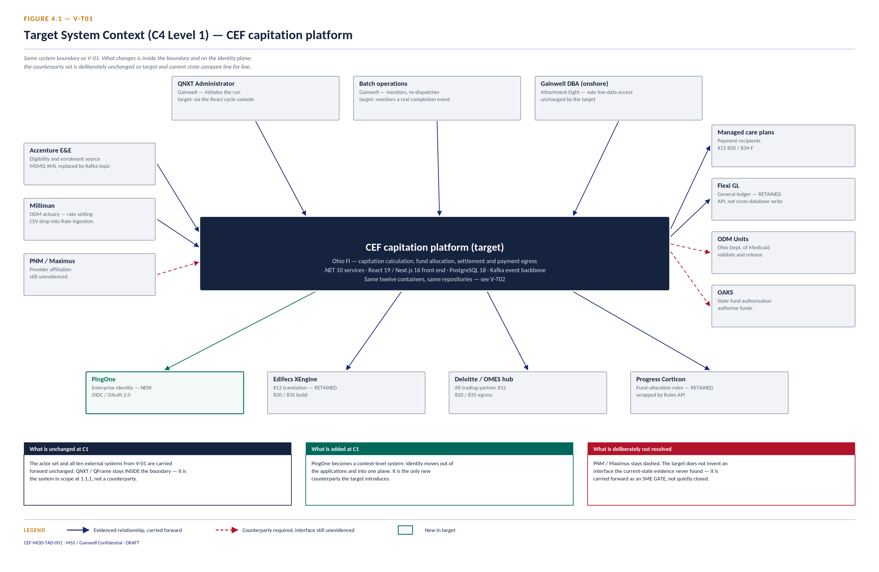
Figure 4.1 — V-T01 System Context, target (C4 Level 1)

The context is deliberately conservative. All ten external systems in V-01 are present here — Accenture E&E, Milliman, PNM/Maximus, the managed care plans, Flexi GL, ODM Units, OAKS, Edifecs, the Deloitte/OMES hub and Progress Corticon — and the three actors are the three V-01 draws: QNXT Administrator, batch operations and the onshore Gainwell DBA. No external interface contract is reopened by the target design. That is a programme-management property as much as an architectural one: renegotiating a trading-partner interface at the same time as re-platforming the runtime would put a third party into the critical path.
QNXT sits inside the boundary, not outside it. §1.1.1 names the QNXT / QFrame capitation agents as the system in scope, and V-01 accordingly places QNXT within the boundary with only the QNXT Administrator appearing as an actor. The target keeps that boundary: the v5.0.31.00 agents are replaced, and the QNXT stores are reached through an anti-corruption layer.
One counterparty is added. PingOne becomes a context-level system because identity moves out of the individual applications and onto a single plane. This is the only new external dependency the target introduces, and §10 of the parent instrument records its tier-zero implications.
One relationship stays dashed. PNM / Maximus is carried forward exactly as V-01 draws it.

4.2 V-T02 — Target Container view

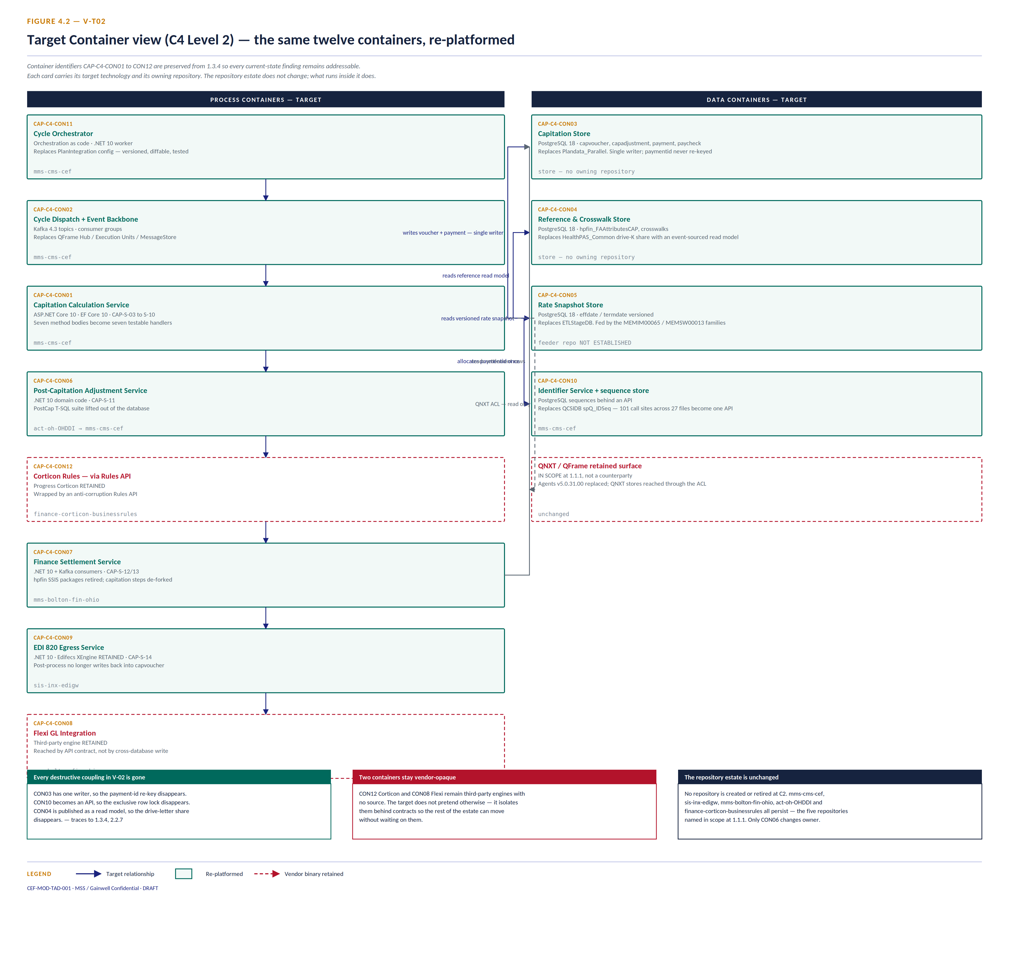
Figure 4.2 — V-T02 Container view, target (C4 Level 2) — the twelve containers re-platformed

The reading order is the same as V-02: process containers on the left, data containers on the right, mechanisms named in the centre gutter.
Three structural changes are worth stating in words as well as in the drawing.
CON03 has one writer. In the current state, capvoucher has seven write paths across four components in three repositories, and PostCap_SplitPayments mutates the primary key after the fact. In the target, the Capitation Calculation Service is the sole writer, the payment identifier is allocated once at the start of the write path, and the key is immutable thereafter. This is the change that makes CON03 a container rather than a de-facto integration bus.
CON02 becomes an event backbone rather than a dispatch fleet. The QFrame Hub, Execution Units and MessageStore are replaced by Kafka topics with consumer groups. The practical difference is not throughput — capitation is not a throughput-bound workload. It is that dispatch becomes observable, ordering becomes explicit, and a failed cycle becomes replayable instead of restart-and-hope.
CON10 stops being a lock. The spQ_IDSeq shared sequence with 101 call sites and page-lock escalation becomes a service backed by PostgreSQL sequences. Independent identifier types no longer block each other.

5. Engineering views — C4 Levels 3 and 4

5.1 V-T03 — Component view, CAP-C4-CON01

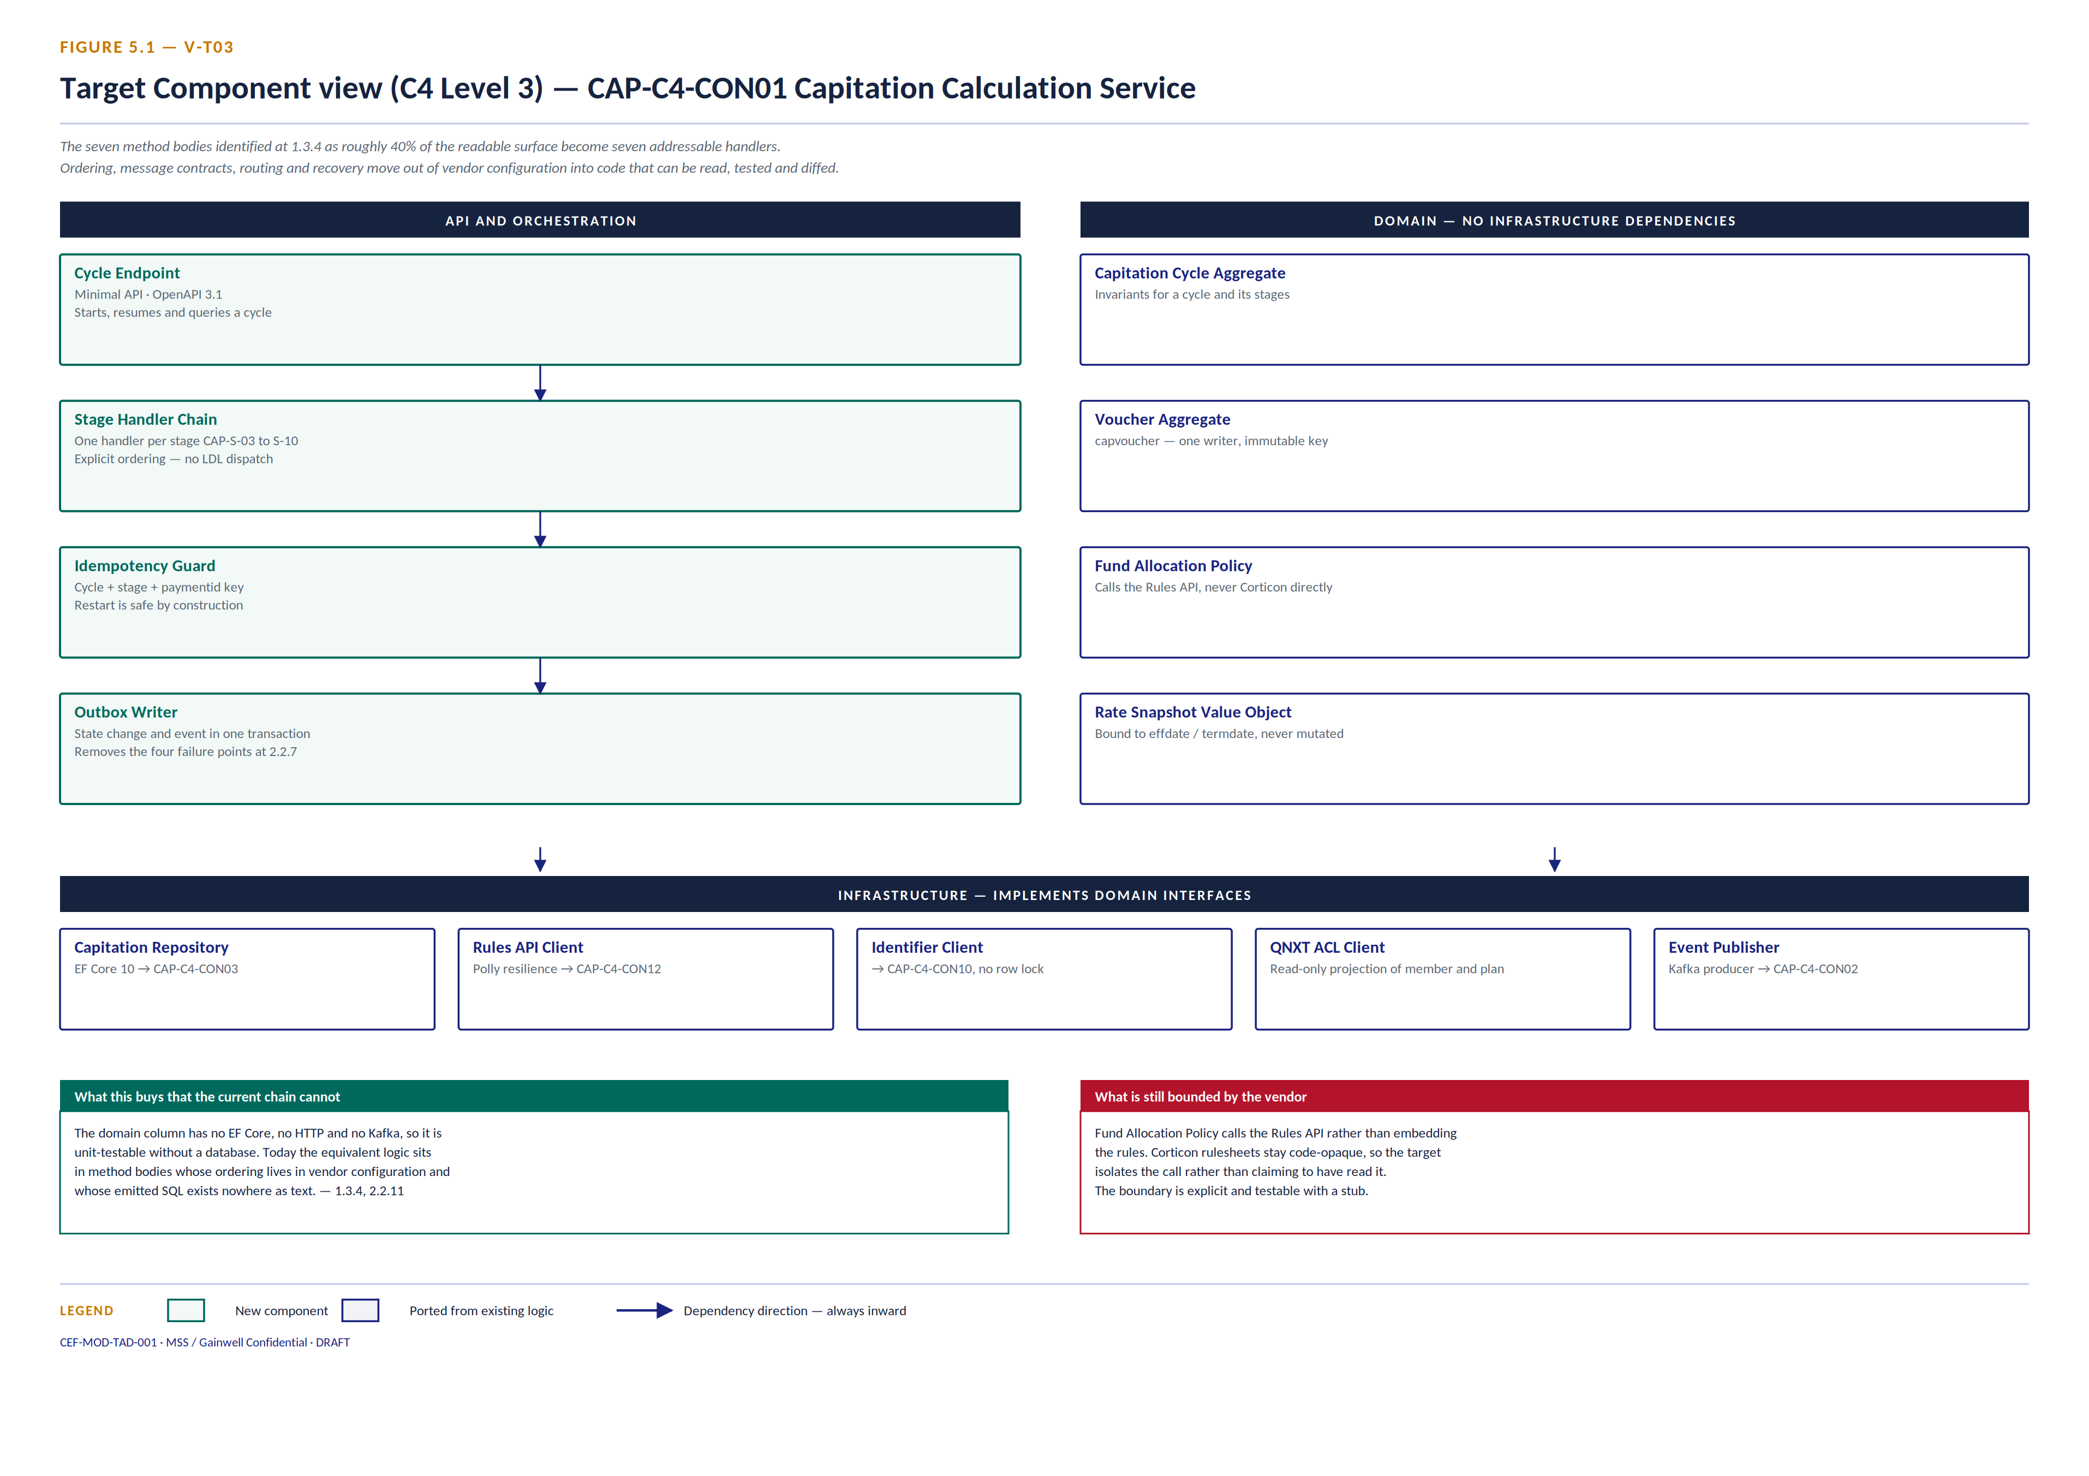
Figure 5.1 — V-T03 Component view, target (C4 Level 3) — CAP-C4-CON01 Capitation Calculation Service

CEF-CAP-TAD-001 §1.3.4 assesses CON01 as partially decomposable: the seven method bodies are readable business logic and account for roughly 40% of the surface, but the sequencing does not transfer because ordering, message contracts, routing and recovery live in configuration and vendor binary.
The target component set is drawn against exactly that finding. The seven method bodies become seven stage handlers in an explicit chain. The sequencing that today lives in QFrame configuration becomes the handler chain itself — code, in version control, with tests. The domain column has no EF Core, no HTTP and no Kafka dependency, which is what makes it unit-testable without a database. That property is the one the current estate most conspicuously lacks, and it is why §2.2.11 records static analysis reaching none of the framework behaviour.

5.2 V-T04 — Code view, the voucher and payment write path

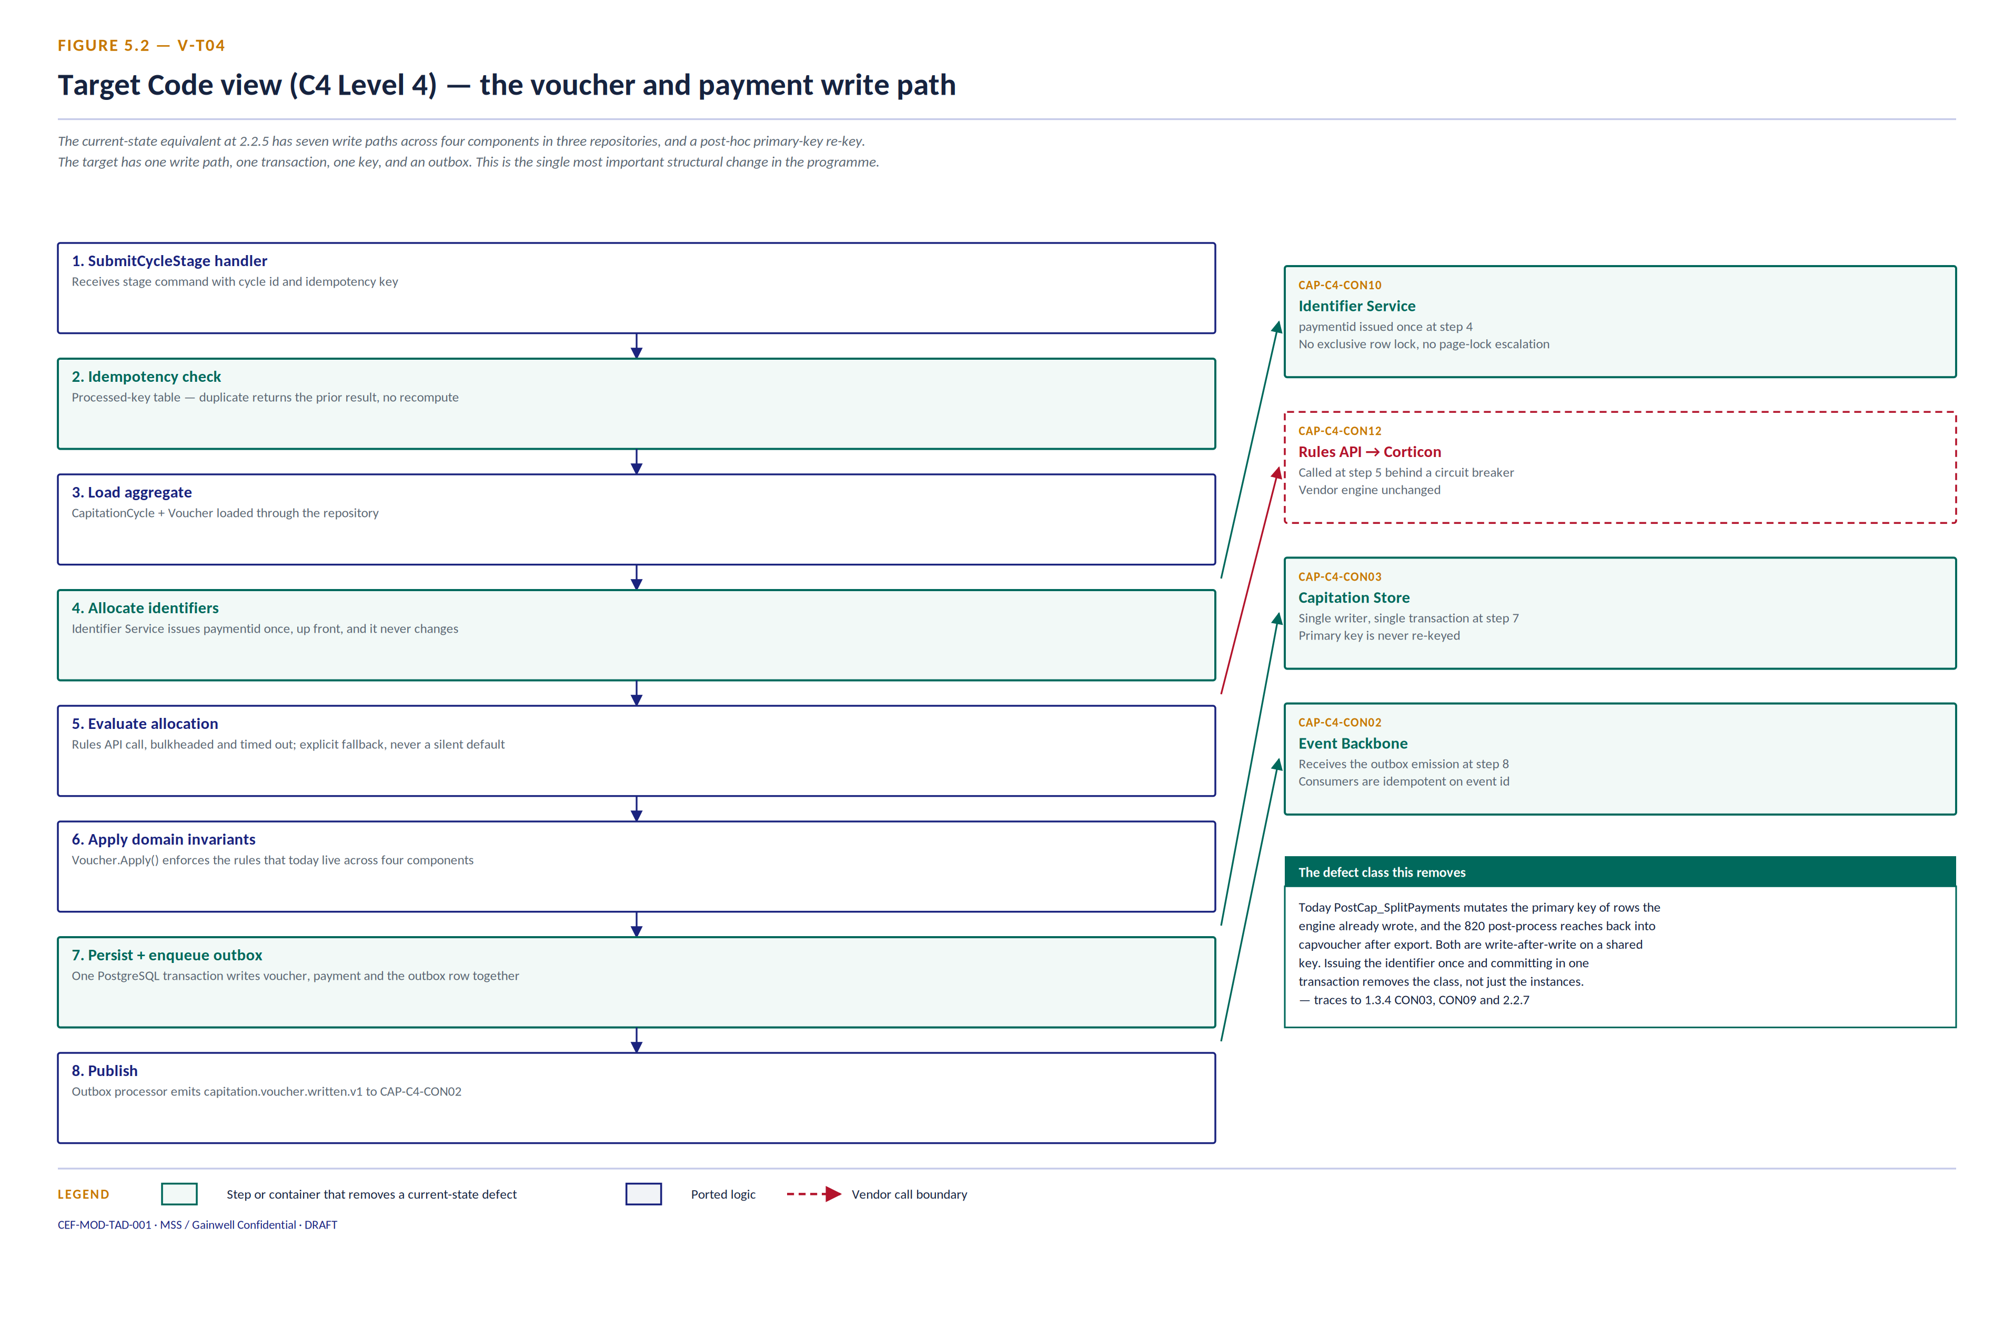
Figure 5.2 — V-T04 Code view, target (C4 Level 4) — the voucher and payment write path

This view is the target counterpart of §2.2.5 and it is the most consequential drawing in the pack.
The current write path issues an identifier, writes, and then re-keys — PostCap_SplitPayments mutates the primary key of rows the engine already wrote, and the 820 post-process reaches back into capvoucher after export. Both are write-after-write against a shared key, and both are why §2.2.7 records four failure points that the restart chain does not clean up.
The target path allocates the identifier once at step 4, commits voucher, payment and the outbox row in one PostgreSQL transaction at step 7, and publishes from the outbox at step 8. Steps 2 and 7 are what make restart safe: the idempotency guard makes a duplicate command a no-op rather than a recompute, and the single transaction makes the state change and the event atomic.
This removes a defect class, not a list of defects. That distinction matters for how the work is estimated. Fixing the instances would be a series of targeted changes to PostCap_SplitPayments and the 820 post-process. Removing the class means the next component that wants to write to capvoucher cannot reintroduce the problem, because there is one writer and the key is immutable.

6. Dynamic views — C4 Level 2

6.1 V-T05 — Target end-to-end capitation, stage grain

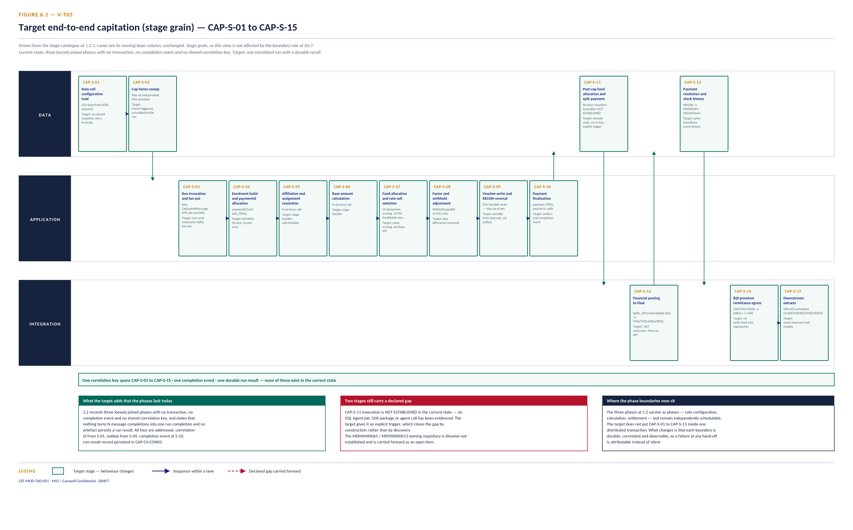
Figure 6.1 — V-T05 End-to-end capitation, target (stage grain) — CAP-S-01 to CAP-S-15

What this view fixes about the current state. §1.2 of the source describes three loosely joined phases and then names four specific absences: no transaction joining them, no completion event, no shared correlation key, and no persisted run result. It adds that nothing turns N message completions into one run completion.
All four are addressed in the target, and it is worth being precise about where:
Absence in current state | Where the target closes it
No transaction joining the phases | Per-stage transactional outbox at CAP-S-09 and CAP-S-10; the phases stay separate but each hand-off is durable
No completion event | CAP-S-10 emits a run-completion event that batch operations can actually monitor against
No shared correlation key | A correlation id is issued at CAP-S-01 and propagates to CAP-S-15
No persisted run result | A run-result record is written to CAP-C4-CON03

Note what the target does not claim: it does not put CAP-S-01 to CAP-S-15 inside one distributed transaction. The phases remain independently schedulable. What changes is that each boundary is durable, correlated and observable.
Two stage-level gaps carried forward. CAP-S-11 invocation is recorded as NOT ESTABLISHED in the source — no SQL Agent job, SSIS package or agent call has been evidenced. The target gives it an explicit trigger, which closes the gap by construction rather than by discovery. That is a legitimate resolution, but it should be recorded as a design decision and not mistaken for a finding.
The owning repository for the MEMIM00065 / MEMSW00013 families is not established at §2.1.4. It is carried forward as O-4 at §8.1.

6.2 V-T06 — Target regular monthly cycle, container grain

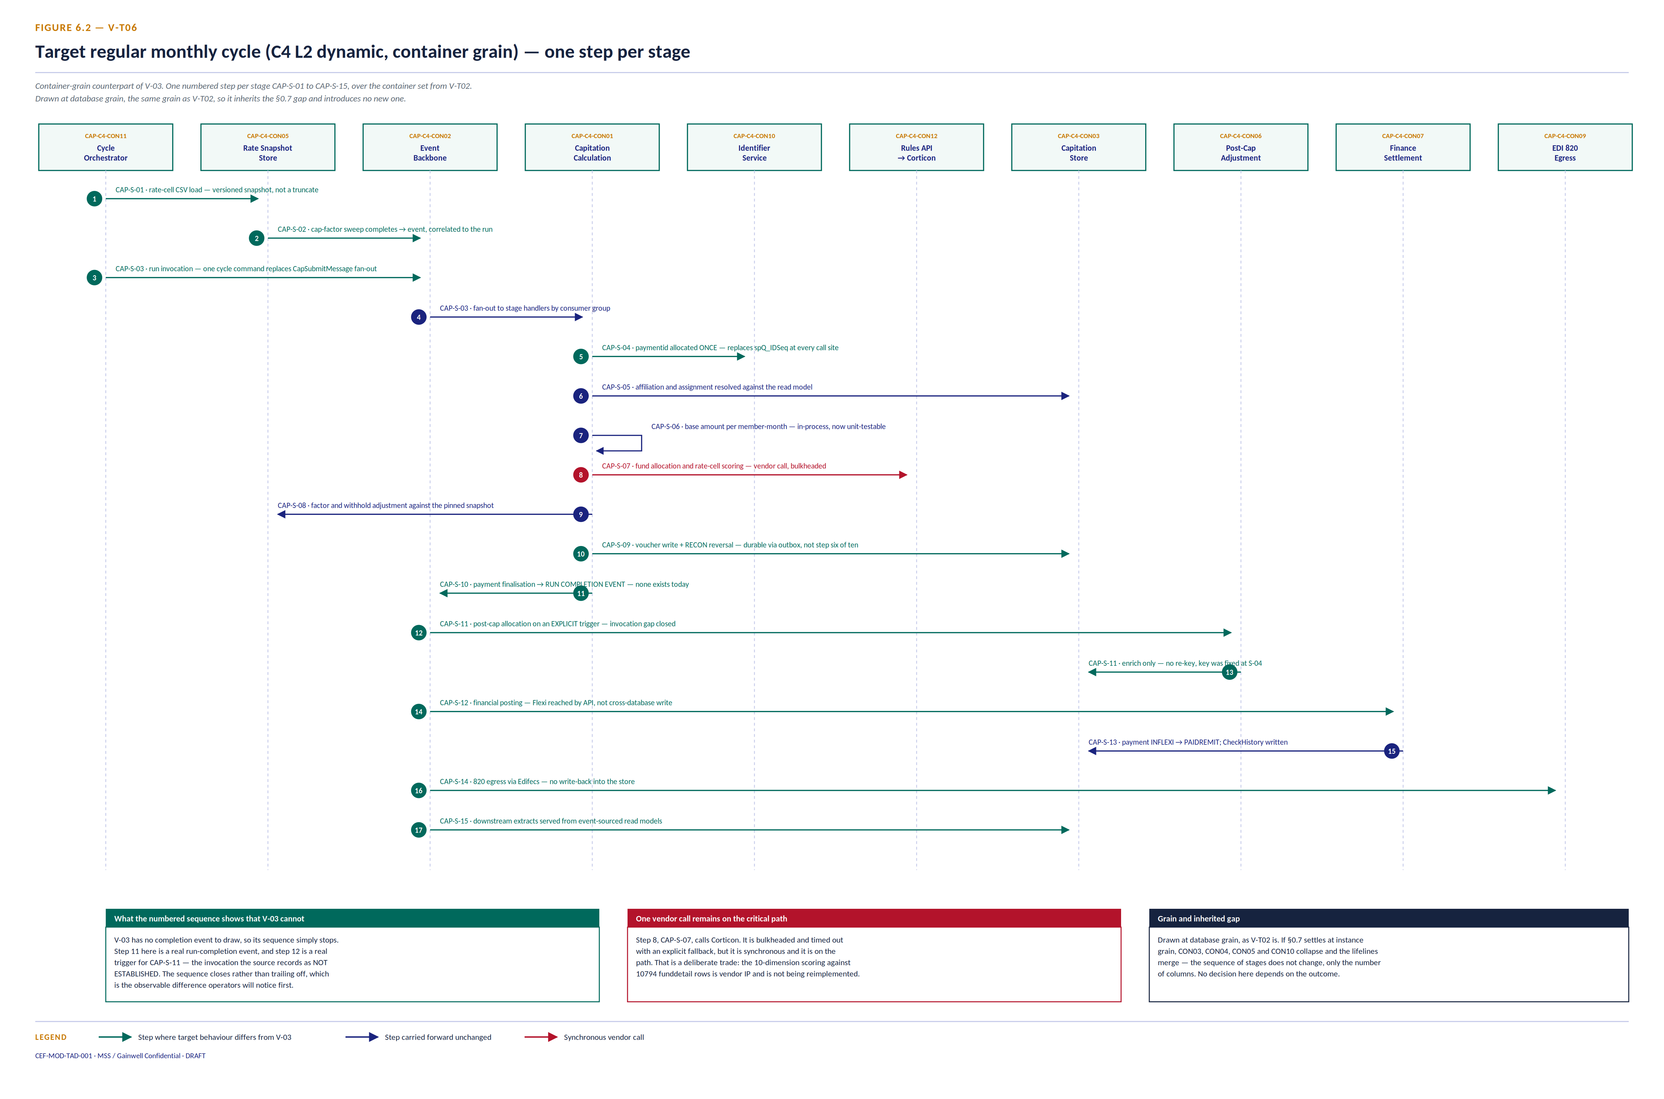
Figure 6.2 — V-T06 Regular monthly cycle, target (C4 L2 dynamic, container grain)

This is the direct counterpart of V-03, drawn to the same construction: one numbered step per stage, over the container set from V-T02, at database grain.
Two things in the sequence are worth reading closely.
Step 11 is a run-completion event. V-03 has no completion event to draw, because §1.2 records that nothing turns N message completions into one run completion. Its sequence therefore stops rather than closing. Here the sequence closes, and batch operations — the actor whose §1.2.2 responsibility is to monitor the cycle — finally has something to monitor against. That is the difference operators will notice first, ahead of any performance change.
Step 12 is an explicit trigger for CAP-S-11. The source records the PostCap invocation as NOT ESTABLISHED: no SQL Agent job, SSIS package or agent call has been evidenced. The target gives it a trigger, which closes the gap by construction. That is a legitimate resolution but it is a design decision, not a discovery, and it should be recorded as such — the current-state question of what invokes it today remains unanswered and still matters for the migration cutover.
One vendor call stays synchronous and on the critical path: step 8, CAP-S-07, into Corticon. It is bulkheaded, timed out and given an explicit fallback, but it is not removed. The 10-dimension scoring against 10794 funddetail rows is vendor IP and is not being reimplemented.

7. Deployment view — C4 Level 2

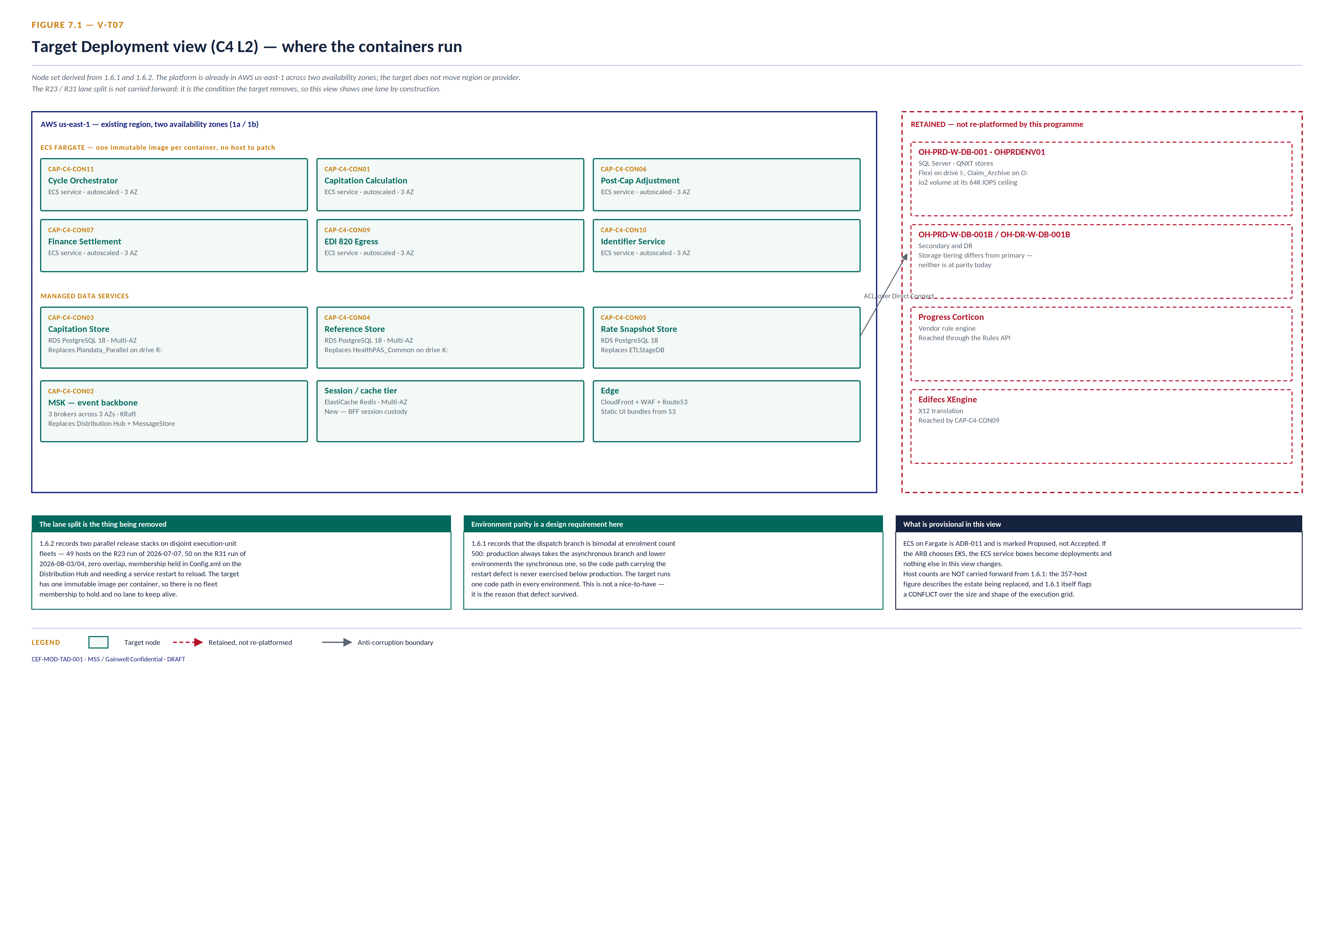
Figure 7.1 — V-T07 Deployment view, target (C4 Level 2)

The node set derives from §1.6.1 and §1.6.2, and the first thing it establishes is that this is not a cloud migration. §1.6.1 records production as AWS us-east-1 across two availability zones. The platform is already there. What changes is EC2 hosts to container services in the same region — which matters for the business case, because it means the AWS line in the financial model is a re-platforming saving on licensing and right-sizing, not a lift-and-shift with all the risk that carries.
Three specific pieces of current-state evidence drive this view.
The lane split is the condition being removed, so it is not drawn. §1.6.2 records two parallel release stacks on disjoint execution-unit fleets — 49 hosts on the R23 run of 2026-07-07, 50 on the R31 run of 2026-08-03/04, zero overlap, membership held in Config.xml on the Distribution Hub host and requiring a service restart to reload. One immutable image per container leaves no fleet membership to hold and no lane to keep alive.
Environment parity is a hard design requirement, not a preference. §1.6.1 records that the dispatch branch is bimodal at enrolment count 500 — production always takes the asynchronous branch, lower environments the synchronous one — so the code path carrying the restart defect is never exercised below production. That is why the defect survived. The target runs one code path in every environment, and that requirement traces directly to this finding.
The IOPS ceiling is a sizing input. Plandata_Parallel sits on an io2 volume at its 64K IOPS ceiling on OH-PRD-W-DB-001. That number is the floor for sizing CAP-C4-CON03 on RDS, and it should be validated in the Phase 1 pilot rather than assumed.
Two things are deliberately not carried into this view. Host counts are excluded: the 357-host figure describes the estate being replaced, and §1.6.1 itself flags a CONFLICT over the size and shape of the execution grid — three numbers for three arguably different things. And ECS on Fargate is marked provisional because ADR-011 is still Proposed; if the ARB chooses EKS, the service boxes become deployments and nothing else in the view changes.

8. Constraints and open items
An architecture that closes every open question on paper is not being honest about its evidence base. Four items are carried forward unresolved, deliberately.
Carried forward | Current-state origin | Why it is not closed here
The container boundary rule — instance or database grain | §0.7, unanswered | Owned by the Solution Architect. Target views inherit database grain for comparability.
PNM / Maximus provider affiliation | V-01, drawn dashed — SME GATE | No interface artefact has been found. Inventing one in the target would misrepresent the evidence.
CON08 Flexi and CON12 Corticon internals | NOT DECOMPOSED, vendor binary | No source, no symbols. Isolation is the only available move.
CON02 emitted SQL | Generated at runtime by the QFrame LDL; exists nowhere as text | The target removes the generator rather than reverse-engineering its output. That is a rewrite, and it must be scoped as one.

The last row is the largest single risk in the programme and should be read carefully. Replacing CON02 is not a port. There is no source to port. It is a rewrite of dispatch, transaction and recovery semantics that are currently observable only by running the system — which is why the migration sequence puts a parallel run with output reconciliation ahead of any cutover on the calculation path.

8.1 Open items
Five items are open. Each has an owner and a consequence if it stays open.

# | Open item | Owner | Consequence if unresolved
O-1 | The container boundary rule at §0.7 — instance grain or database grain | Solution Architect | V-T02 and V-T06 are drawn at database grain. If it settles at instance grain, CON03, CON04, CON05 and CON10 collapse and the views are redrawn. No decision in this pack depends on the outcome.
O-2 | ADR-011 — ECS on Fargate or EKS | Platform architecture | V-T07 is drawn provisionally. If EKS is chosen, the service boxes become deployments and nothing else in the view changes.
O-3 | What invokes the PostCap procedures at CAP-S-11 today | Gainwell SME | The target gives CAP-S-11 an explicit trigger, but the current invocation is still unevidenced and it matters for cutover sequencing.
O-4 | Owning repository for the MEMIM00065 / MEMSW00013 SSIS families | Gainwell platform engineering | CAP-C4-CON05 has a target design but no confirmed owning repository, so its migration cannot yet be assigned to a team.
O-5 | R23 / R31 cutover decision | Gainwell platform engineering | mms-cms-cef-r23 is not present in the workspace and no target disposition is asserted for it. The target assumes one lane; that assumption needs confirming.

Two boundaries are permanent rather than open. CAP-C4-CON08 Flexi and CAP-C4-CON12 Corticon are third-party engines with no available source or symbols. The target isolates them behind contracts; it does not decompose them.
One structural point about maintenance. §0.7 of the parent instrument states that the ArchiMate model in its Appendix B is authoritative and that C4 views are derived from it, and warns that maintaining both by hand means they disagree within one revision. Appendix B.1 is currently unpopulated, so these views are hand-maintained. If the model is populated later, these views should be regenerated from it rather than edited alongside it.

9. Consistency check
The check CEF-CAP-TAD-001 applies at §1.8.4 is applied here in the same form.
Check | Result
Every container in V-T02 traces to a container in V-02 through its CAP-C4-CON identifier | Pass — twelve to twelve
Every container in V-T02 names an owning repository from the §2.1.4 inventory | Pass
Every relationship crossing a process boundary names its mechanism | Pass
Every external system in V-T01 appears in V-01 | Pass, plus PingOne, which is declared as the single addition
Every current-state coupling finding at §1.3.4 has a named target disposition | Pass — see §3.1
Views are drawn at a single, declared grain | Pass — database grain, inherited from V-02, gap declared at §2.2
A dynamic view is drawn | Pass — V-T05 at stage grain (Figure 6.1) and V-T06 at container grain (Figure 6.2)
Deployment view is drawn | Pass — V-T07, Figure 7.1
Every element traces to a statement in the parent instrument | Pass

All nine pass. The target view set is now complete at every C4 level the source models: L1, L2 container, L2 dynamic at two grains, L2 deployment, L3 and L4.

10. Actions
Audience | Action
Solution Architect | Close §0.7 (O-1) and populate Appendix B.1. Both view sets depend on the first; §8.1 explains why the second matters more than it looks.
Architecture Review Board | Accept or reject the container traceability at §3.1. It is the contract between current and target state; everything downstream depends on it holding.
Delivery leads | Read §4 before estimating. CON02 is a rewrite, not a port, and estimating it as a port is the most likely way this programme goes wrong.
Programme management | Note that no external interface contract reopens and only one repository boundary moves. Those two facts are what keep the migration sequenceable.

